**University of Mumbai**

**Nana Vanjare Vidyanagari**

**New Education Society’s**

**ARTS,COMMERCE & SCIENCE COLLEGE,LANJA**

Tal.-Lanja , Dist.- Ratnagiri. Phone:(02351)230558



**Submitted to**

**University of Mumbai**

**Project Report on**

# Chemistry Laboratory Management

**By**

**Mr.Jayesh Deepak lokare**

T.Y.B.Sc.**(Computer Science)**

**Project Guide:**

**Prof. Mr.Anup Saredesai**

**Department of Computer Science**

**Year Duration**

**2022-2023**

**University of Mumbai**

**Nana Vanjare Vidyanagari**

**New Education Society’s**

**ARTS,COMMERCE & SCIENCE COLLEGE,LANJA**

Tal.-Lanja , Dist.- Ratnagiri. Phone:(02351)230558



**DEPARTMENT OF COMPUTER SCIENCE**

**CERTIFICATE**

This is to certify that, **Mr. Jayesh Deepak Lokare** of T.Y.B.Sc. (CS) class bearing examination Seat No. has satisfactorily carried out Online exmination system projection as laid down by the University of Mumbai for the year 2022-2023. His computer science department work was completed under the guidance of **Miss.anup saredesai**

**Signature of Examiner Head of Department**

**Guide Computer Science**

**Place: - Lanja**

**Date:**

**INDEX**

|  |  |  |  |
| --- | --- | --- | --- |
| **SR. N0** | **TITLE** | **PAGE NO.** | |
| 1) | **ACKNOWLEDGEMENT** | 1 | |
| 2) | **PRELIMINARY INVESTIGATION** | 2 | |
| 3) | **DESCRIPTION OF SYSTEM** | 3 | |
| 4) | **ADVANTAGE OF PROPOSED SYSTEM** | 4 | |
| 5) | **FUNCTIONAL REQUIRMENTS** | 4 | |
| 6) | **STAKEHOLDERS** | 5 | |
| 7) | **SYSTEM ANALYSIS** | 6 | |
| 8) | **Technical Details** | 7 | |
| 9) | **SYSTEM DESIGN** | | 8 | |
| 10) | **SYSTEM CODING AND LAYOUT** | | 11 | |
| 11) | **Conclusion** | | 44 | |
| 12) | **Future scope** | | 44 | |
| 13) | **References** | | 45 | |

**ACKNOWLEDGEMENT**

It is my prime duty to offer my sincere gratitude to University of Mumbai to include the project work in the syllabus of Third Year Bachelor’s Degree so as to develop interest about research work among the students like us.

I wish to express my sincere thanks to **Asst. Prof. A.O.Keluskar**, Head of the Department of Computer Science for giving me the opportunity to complete the project work by providing facilities in the department and providing valuable guidance to complete the task.

I am greatly obliged to **Mr. Anup Saredesai**, lecturer in Department of Computer Science who provided valuable guidelines and conceptual guidance throughout the project work also helped out in clearing about the project.

I also grateful to Dr.A. S. Kulkarni , principle of Shreeram Kusumtai Sadashiv Vanjare College, Lanja for providing all necessary facilities of laboratory and library at Shreeram Kusumtai Sadashiv Vanjare College, Lanja.

Last but not the least my special thanks to my parents, my friends and all those people who have encourage me, helped me to complete this course successfully in time.

Mr.Jayesh Deepak Lokare

**Preliminary Investigation and**

**Requirement specification**

**1: Organizational Overview :**

* **Topic of the project: online examination system**
* **Front End: HTML ,CSS ,JavaScript,Bootstrap**
* **Back End: PHP , MYSQL**

Proposed System:

**This application is used to conduct online examination. The students can sit at individual terminals and login to write the exam in the given duration. . The questions have to be given to the students.This application will perform correction, display the result immediately and also store it in database. This application provides the administrator with a facility to add new exams.This application provides the Instructor add questions to the exam, modify questions in the exam in a particular exam. This application takes care of authentication of the administrator,Instructor as well as the student.**

**Scope of the project:**

Existing system is a manual one in which users are maintaining books to store the information like Student Details,Instructor Details,Schedule Details and feedback about students who attempted exam as per schedule.. It is very difficult to maintain historical data.

**DESCRIPTION OF SYSTEM**

This project is designed with simplicity of mind. Care has been taken so that it is user friendly and has a good interface, which gives the user a decent experience.

* **Requirements:**
* Network connection
* **Software’s used:**
* Web Browser
* Xampp:
  + Apache:
  + MySqlServer
* **Languages used:**
* PHP
* JavaScript
* HTML
* CSS
* BootStrap

**Advantage of Proposed system**

1. Easy to understand by user & operators.
2. Easy to operate.
3. Have a good User Interface (UI).
4. Easy to navigate
5. Provides all the comprehensive information of available stocks in lab

**Stakeholders**

There are users for this system.

**Admin :**

Admin is responsible for update details of Web application. Admin also manages all the data information on Web application .

**Users :**

Users will be the staff member in the or examiner

**SYSTEM ANALYSIS**

Existing system is a manual one in which users are maintaining books to store the information like Student Details,Instructor Details,Schedule Details and feedbacks about students who attempted exam as per schedule.. It is very difficult to maintain historical data.

DISADVANTAGES:

The following drawbacks of existing system emphasize the need for computerization:

1. A lot of copies of question papers have to be made

2. A lot of correction work hence delay in giving the results

3. A lot of tabulation work for each subject results

2. Proposed System:

**This application is used to conduct online examination. The students can sit at individual terminals and login to write the exam in the given duration. . The questions have to be given to the students.This application will perform correction, display the result immediately and also store it in database. This application provides the administrator with a facility to add new exams.This application provides the Instructor add questions to the exam, modify questions in the exam in a particular exam. This application takes care of authentication of the administrator,Instructor as well as the student.**

**Technical Details**

**Name of the Project :**

Online Examination System

**Designer of the Project :**

Mr Jayesh Deepak Lokare

T.Y.Bsc. Computer Science,

Shreeram Kusumtai Sadashiv Vanjare

College, Lanja, Dist-Ratnagiri

SYSTEM DESIGN

**DFD diagram:**

User registrationn

Take Test

Online Examinationn

Database

**Sequence diagram:**

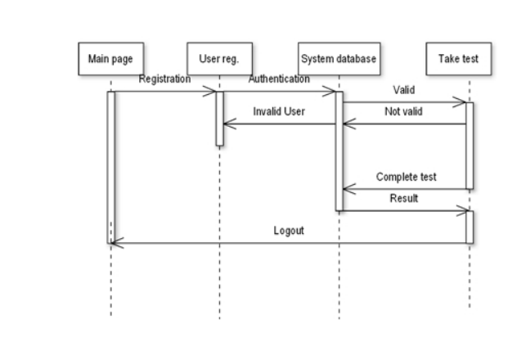

**Taking Test**

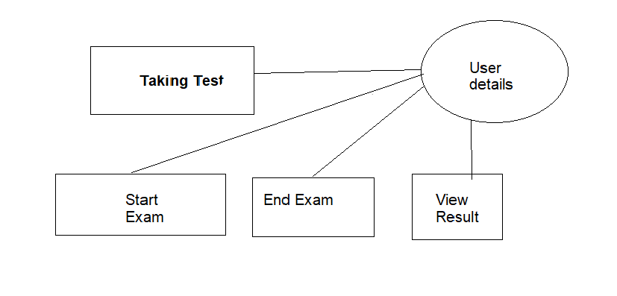

**USE CASE diagram:**

A Use case is a description of set of sequence of actions. Graphically it is rendered as an ellipse with solid line including only its name. Use case diagram is a behavioral diagram that shows a set of use cases and actors and their relationship. It is an association between the use cases and actors. An actor represents a real-world object. Primary Actor – Sender, Secondary ActorReceiver.

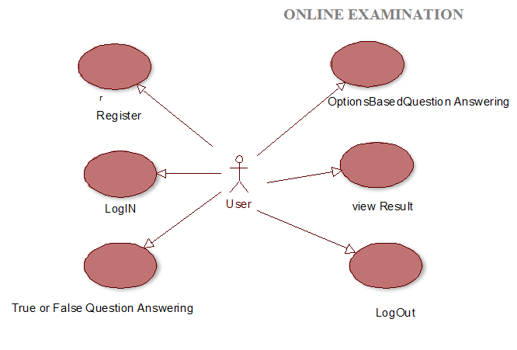

**ER diagram:**

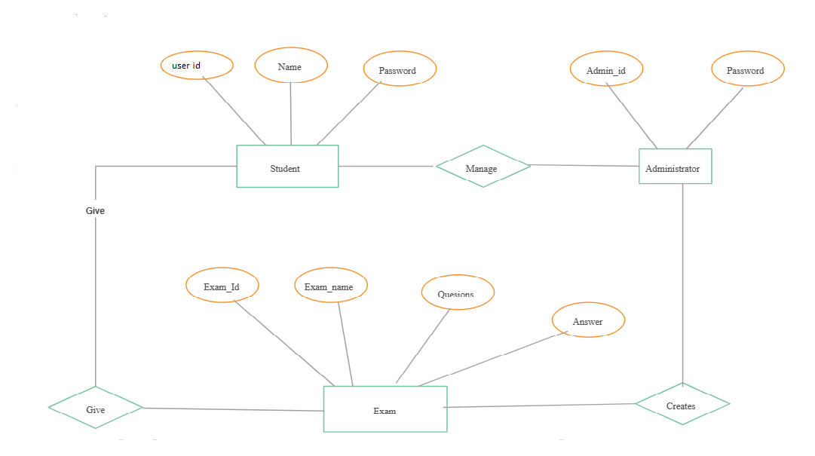

SYSTEM CODING AND LAYOUT

**Screen Layouts and Report Layouts:**

**Login page:**

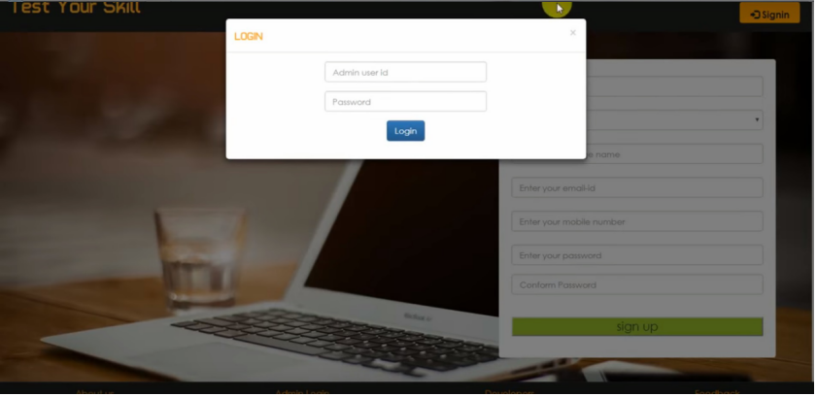

<!DOCTYPE html PUBLIC "-//W3C//DTD XHTML 1.0 Transitional//EN" "http://www.w3.org/TR/xhtml1/DTD/xhtml1-transitional.dtd">

<html xmlns="http://www.w3.org/1999/xhtml">

<head>

<meta http-equiv="Content-Type" content="text/html; charset=iso-8859-1" />

<meta name="viewport" content="width=device-width, initial-scale=1">

<title>Project Worlds || TEST YOUR SKILL </title>

<link rel="stylesheet" href="css/bootstrap.min.css"/>

<link rel="stylesheet" href="css/bootstrap-theme.min.css"/>

<link rel="stylesheet" href="css/main.css">

<link rel="stylesheet" href="css/font.css">

<script src="js/jquery.js" type="text/javascript"></script>

<script src="js/bootstrap.min.js" type="text/javascript"></script>

<link href='http://fonts.googleapis.com/css?family=Roboto:400,700,300' rel='stylesheet' type='text/css'>

<?php if(@$_GET['w'])

{echo'<script>alert("'.@$_GET['w'].'");</script>';}

?>

<script>

function validateForm() {var y = document.forms["form"]["name"].value; var letters = /^[A-Za-z]+$/;if (y == null || y == "") {alert("Name must be filled out.");return false;}var z =document.forms["form"]["college"].value;if (z == null || z == "") {alert("college must be filled out.");return false;}var x = document.forms["form"]["email"].value;var atpos = x.indexOf("@");

var dotpos = x.lastIndexOf(".");if (atpos<1 || dotpos<atpos+2 || dotpos+2>=x.length) {alert("Not a valid e-mail address.");return false;}var a = document.forms["form"]["password"].value;if(a == null || a == ""){alert("Password must be filled out");return false;}if(a.length<5 || a.length>25){alert("Passwords must be 5 to 25 characters long.");return false;}

var b = document.forms["form"]["cpassword"].value;if (a!=b){alert("Passwords must match.");return false;}}

</script>

</head>

<body>

<div class="header">

<div class="row">

<div class="col-lg-6">

<span class="logo">Test Your Skill</span></div>

<div class="col-md-2 col-md-offset-4">

<a href="#" class="pull-right btn sub1" data-toggle="modal" data-target="#myModal"><span class="glyphicon glyphicon-log-in" aria-hidden="true"></span>&nbsp;<span class="title1"><b>Signin</b></span></a></div>

<!--sign in modal start-->

<div class="modal fade" id="myModal">

<div class="modal-dialog">

<div class="modal-content title1">

<div class="modal-header">

<button type="button" class="close" data-dismiss="modal" aria-label="Close"><span aria-hidden="true">&times;</span></button>

<h4 class="modal-title title1"><span style="color:orange">Log In</span></h4>

</div>

<div class="modal-body">

<form class="form-horizontal" action="login.php?q=index.php" method="POST">

<fieldset>

<!-- Text input-->

<div class="form-group">

<label class="col-md-3 control-label" for="email"></label>

<div class="col-md-6">

<input id="email" name="email" placeholder="Enter your email-id" class="form-control input-md" type="email">

</div>

</div>

<!-- Password input-->

<div class="form-group">

<label class="col-md-3 control-label" for="password"></label>

<div class="col-md-6">

<input id="password" name="password" placeholder="Enter your Password" class="form-control input-md" type="password">

</div>

</div>

</div>

<div class="modal-footer">

<button type="button" class="btn btn-default" data-dismiss="modal">Close</button>

<button type="submit" class="btn btn-primary">Log in</button>

</fieldset>

</form>

</div>

</div><!-- /.modal-content -->

</div><!-- /.modal-dialog -->

</div><!-- /.modal -->

<!--sign in modal closed-->

</div><!--header row closed-->

</div>

<div class="bg1">

<div class="row">

<div class="col-md-7"></div>

<div class="col-md-4 panel">

<!-- sign in form begins -->

<form class="form-horizontal" name="form" action="sign.php?q=account.php" onSubmit="return validateForm()" method="POST">

<fieldset>

<!-- Text input-->

<div class="form-group">

<label class="col-md-12 control-label" for="name"></label>

<div class="col-md-12">

<input id="name" name="name" placeholder="Enter your name" class="form-control input-md" type="text">

</div>

</div>

<!-- Text input-->

<div class="form-group">

<label class="col-md-12 control-label" for="gender"></label>

<div class="col-md-12">

<select id="gender" name="gender" placeholder="Enter your gender" class="form-control input-md" >

<option value="Male">Select Gender</option>

<option value="M">Male</option>

<option value="F">Female</option> </select>

</div>

</div>

<!-- Text input-->

<div class="form-group">

<label class="col-md-12 control-label" for="name"></label>

<div class="col-md-12">

<input id="college" name="college" placeholder="Enter your college name" class="form-control input-md" type="text">

</div>

</div>

<!-- Text input-->

<div class="form-group">

<label class="col-md-12 control-label title1" for="email"></label>

<div class="col-md-12">

<input id="email" name="email" placeholder="Enter your email-id" class="form-control input-md" type="email">

</div>

</div>

<!-- Text input-->

<div class="form-group">

<label class="col-md-12 control-label" for="mob"></label>

<div class="col-md-12">

<input id="mob" name="mob" placeholder="Enter your mobile number" class="form-control input-md" type="number">

</div>

</div>

<!-- Text input-->

<div class="form-group">

<label class="col-md-12 control-label" for="password"></label>

<div class="col-md-12">

<input id="password" name="password" placeholder="Enter your password" class="form-control input-md" type="password">

</div>

</div>

<div class="form-group">

<label class="col-md-12control-label" for="cpassword"></label>

<div class="col-md-12">

<input id="cpassword" name="cpassword" placeholder="Conform Password" class="form-control input-md" type="password">

</div>

</div>

<?php if(@$_GET['q7'])

{ echo'<p style="color:red;font-size:15px;">'.@$_GET['q7'];}?>

<!-- Button -->

<div class="form-group">

<label class="col-md-12 control-label" for=""></label>

<div class="col-md-12">

<input type="submit" class="sub" value="sign up" class="btn btn-primary"/>

</div>

</div>

</fieldset>

</form>

</div><!--col-md-6 end-->

</div></div>

</div><!--container end-->

<!--Footer start-->

<div class="row footer">

<!--<div class="col-md-3 box">

<a href="http://www.projectworlds/online-examination" target="_blank">About us</a>

</div>-->

<div class="col-md-3 box">

<a href="#" data-toggle="modal" data-target="#login">Admin Login</a></div>

<div class="col-md-3 box">

<a href="#" data-toggle="modal" data-target="#developers">Developers</a>

</div>

<div class="col-md-3 box">

<a href="feedback.php" target="_blank">Feedback</a></div></div>

<!-- Modal For Developers-->

<div class="modal fade title1" id="developers">

<div class="modal-dialog">

<div class="modal-content">

<div class="modal-header">

<button type="button" class="close" data-dismiss="modal"><span aria-hidden="true">&times;</span><span class="sr-only">Close</span></button>

<h4 class="modal-title" style="font-family:'typo' "><span style="color:orange">Developer</span></h4>

</div>

<div class="modal-body">

<p>

<div class="row">

<div class="col-md-4">

<img src="image\IMG-20220105-WA0002.jpg" width=100 height=100 alt="Sunny Prakash Tiwari" class="img-rounded">

</div>

<div class="col-md-5">

<a href="http://yugeshverma.blogspot.in" style="color:#202020; font-family:'typo' ; font-size:18px" title="Find on Facebook">Jayesh lokare</a>

<h4 style="color:#202020; font-family:'typo' ;font-size:16px" class="title1">+91 9145798127</h4>

<h4 style="font-family:'typo' ">jayeshlokare76@gmail.com</h4>

<h4 style="font-family:'typo' ">ACS college Lanja</h4></div></div>

</p>

</div>

</div><!-- /.modal-content -->

</div><!-- /.modal-dialog -->

</div><!-- /.modal -->

<!--Modal for admin login-->

<div class="modal fade" id="login">

<div class="modal-dialog">

<div class="modal-content">

<div class="modal-header">

<button type="button" class="close" data-dismiss="modal"><span aria-hidden="true">&times;</span><span class="sr-only">Close</span></button>

<h4 class="modal-title"><span style="color:orange;font-family:'typo' ">LOGIN</span></h4>

</div>

<div class="modal-body title1">

<div class="row">

<div class="col-md-3"></div>

<div class="col-md-6">

<form role="form" method="post" action="admin.php?q=index.php">

<div class="form-group">

<input type="text" name="uname" maxlength="20" placeholder="Admin user id" class="form-control"/>

</div>

<div class="form-group">

<input type="password" name="password" maxlength="15" placeholder="Password" class="form-control"/>

</div>

<div class="form-group" align="center">

<input type="submit" name="login" value="Login" class="btn btn-primary" />

</div>

</form>

</div><div class="col-md-3"></div></div>

</div>

<!--<div class="modal-footer">

<button type="button" class="btn btn-default" data-dismiss="modal">Close</button>

</div>-->

</div><!-- /.modal-content -->

</div><!-- /.modal-dialog -->

</div><!-- /.modal -->

<!--footer end-->

</body>

</html>

## Home Page:

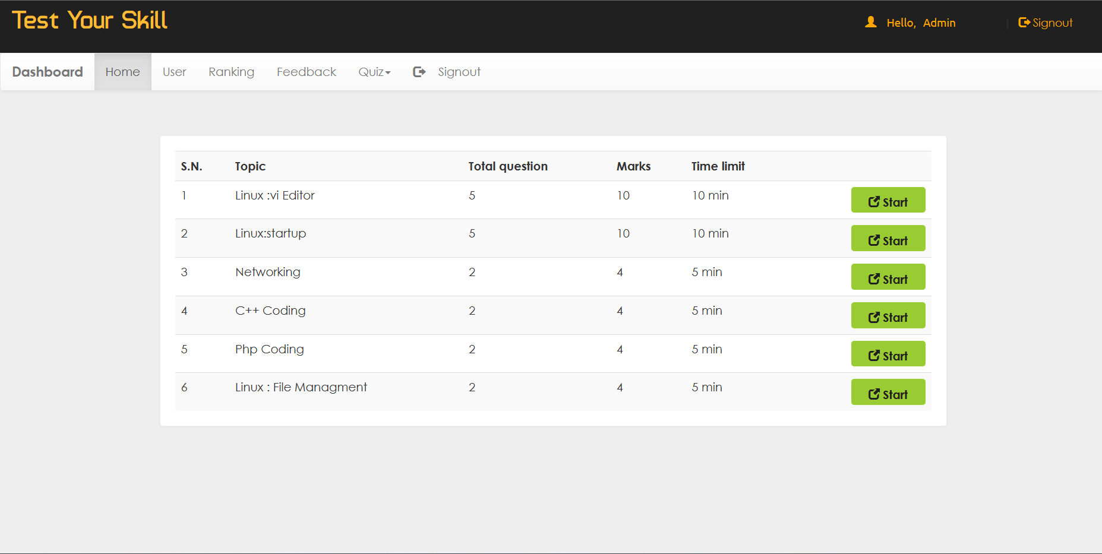

## User Information

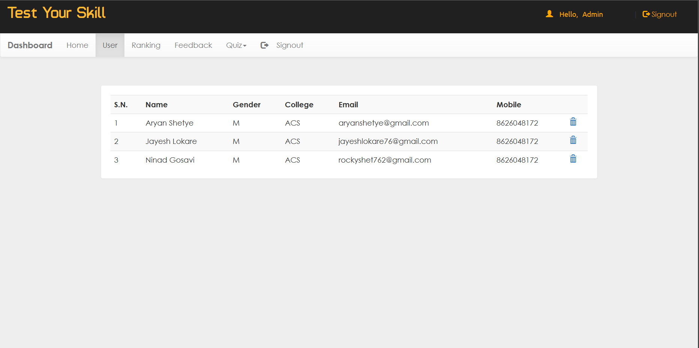

## Ranking Page:

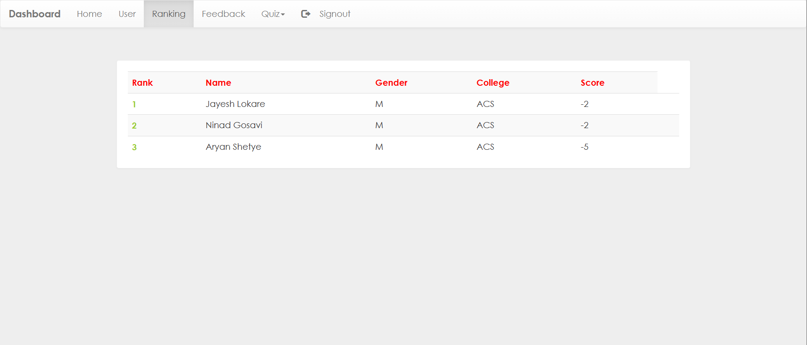

## Feedback Page:

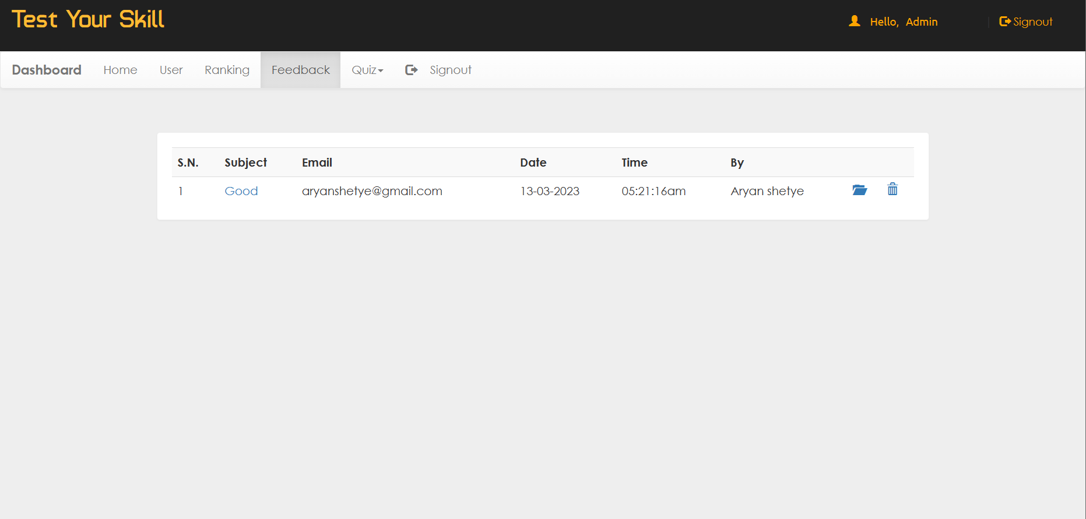

## Quiz Page:

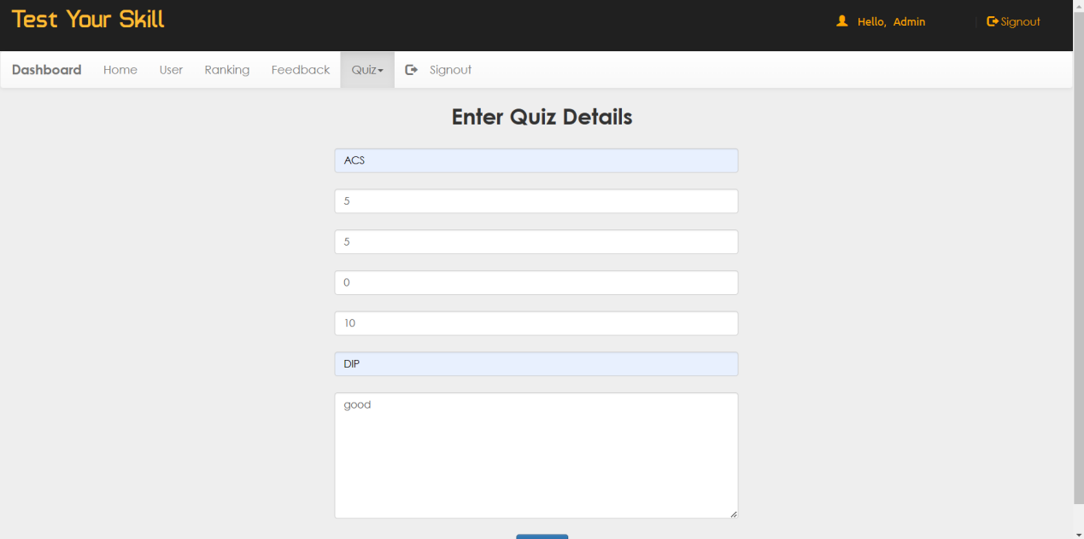

## Feedback:

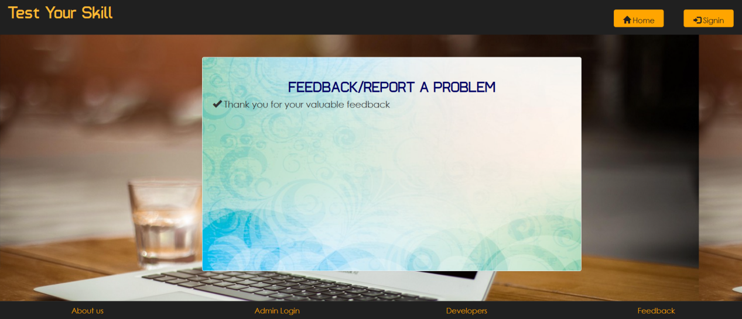

## Developer Information:

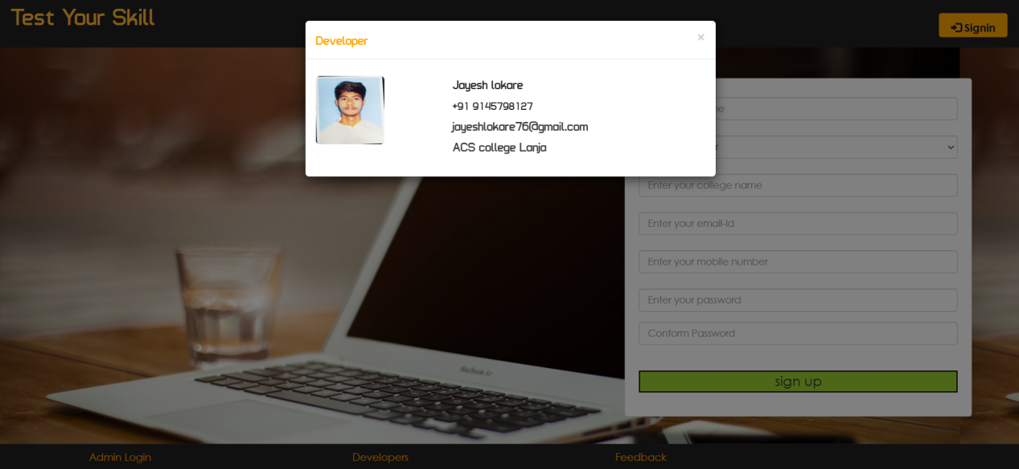

**Conclusion**

It was a wonderful and learning experience for me while working on this project. It was due to this project I came to know how professional website’s are designed.

I enjoy each and every bit of work I had put into this project. The

project is further extendable.

**Future scope**

1. Reduction of paper work.
2. Human efforts can be reduced.
3. Adding more services.
4. Web application will be more users friendly.
5. Web application will be used for other college.

**References**

1. [www.youtube.com](http://www.youtube.com/)
2. [www.google.com](http://www.google.com/)
3. 1 Source Code (youtube)
4. [www.tailwind.com](http://www.tailwind.com)